# **Destination 2055 Alternative Futures Survey**

Welcome!  The purpose of this survey is to better understand community desires for the Triangle Region's future transportation system. What key elements/attributes should be carried forward into a single preferred alternative for further analysis and sorting of transportation projects into 10-year buckets?

**What is an MTP?**

A Metropolitan Transportation Plan is the guide for **future investments in roads, transit (bus and rail) services, bicycle and pedestrian facilities to match the growth expected** in the Research Triangle Region.

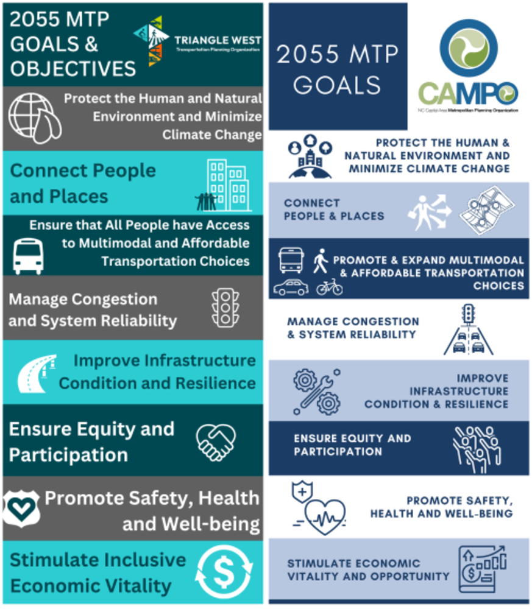The Triangle region has two Metropolitan Planning Organizations (MPOs), who are working together to develop one 2055 Metropolitan Transportation Plan ("Destination 2055") for the region. Over the past year, they have jointly conducted public engagement around the topics of overall goals and objectives for the 2055 MTP and identified performance measures to track progress over time.

 Alternatives Analysis – What are our Future Needs?

To analyze the transportation investment choices we have, the MPOs followed a systematic process that began with an **understanding of how our communities’ plans** envision guiding future growth. Next, planners used sophisticated software to **forecast**the types, locations and amounts of **future population and jobs growth** based on market conditions and trends, factors that influence development, and local plans.  Based on the forecasts, they looked at mobility trends and needs, and **where our transportation system may become deficient** in meeting these needs.

Alternatives Analysis – Evaluate Potential Solutions

Working with a variety of partners and based on public input, **three (3) different transportation system alternative future scenarios** and are currently being and analyzed - comparing the alternatives against one another to see how they perform.

What is the **main way you get around** for most daily trips?

* Bicycle
* Carpool
* Drive Alone
* Taxi/Rideshare
* Transit (Bus or Rail)
* Walk
* Other ________________________________________________

***How many motor vehicles*** are available for use in your household?

* 0
* 1
* 2
* 3
* 4 or more

Please provide your **home zip code**: __________

Please provide your **work/school** zip code, if applicable: __________

How did you learn about this survey?

* Email Blast
* Digital/Online News Article
* Print News Article
* Website
* Flyer
* Facebook
* Instagram
* Nextdoor/Neighborhood Email
* Twitter
* Word of Mouth/Friend
* Other ____________________

With the **future transportation system for the Triangle Region**in mind, please answer the following questions about **your priorities** for roadway, transit, and bicycle/pedestrian investments.

For **transit** specifically, which of the following do you prefer?

* **Limited Improvements**: Additional bus routes and increased frequencies, bus rapid transit gets focused more in urbanized areas, no investments are made in rail improvement.
* **Moderate Improvements**: Additional bus routes and increased frequencies that expand beyond urbanized areas, more rapid bus transit expansion, and increased service on existing rail routes and new rail facilities.
* **Enhanced Improvements**: Additional bus routes and increased frequencies that expand beyond urbanized areas, even more rapid bus transit expansion across the region, and increased rail facilities, including regional rail connections.
* **No further** **improvements** to transit in the region.

For **bicycle and pedestrian facilities** specifically, which do you prefer?

* **Limited Improvements** such as adding painted bike lanes on existing roadways.
* **Moderate Improvements** such as protected bike lanes, multi-use paths (or side paths) and trails/greenways.
* **Enhanced Improvements** such as upgrading existing roadway facilities with emphasis on protected lanes for bicycles that are also separated from pedestrians, multi-use paths and trails/greenways.
* **No further improvements** to bicycle/pedestrian facilities in the region.

For **land development patterns** specifically, which do you prefer?

* **Limited** changes to the land development pattern that includes more residential and commercial development in more rural areas.
* **Moderate** changes to the land development pattern that includes more concentrated new development in existing communities.
* **Advanced** changes to the land development pattern that includes more concentrated new developments and redevelopment in existing communities.

For **roadway investments** specifically, which do you prefer?

* **Limited**: Maintaining existing roads with few or no new lanes or roads; Prioritize low-cost improvements like better signal timing, safety enhancements at key intersections while managing congestion through other modes (transit, biking, walking).
* **Moderate**: Maintain and modernize existing roads with expansion of key roads and intersections where congestion or safety issues are most severe; Balanced approach with moderate emphasis on improving car travel alongside investments in other modes.
* **Enhanced**: Major investments in expanding road capacity (new lanes, new roads, bypasses, and interchanges focused on reducing congestion and travel times for cars and freight. Greater use of advanced traffic management technologies (e.g., smart signals, real-time traffic info).
* **No further** investments in roadways in the region.

Please **Rank** the following seven (7) **priorities** for our region's future transportation system from most important to least important.   
*(Place a number 1-7 next to each priority with* ***1 as the most important****.)*

_____ Reducing traffic congestion (through road widenings and new road connections)

_____ Expanding public transit options (more bus routes, rail lines, and transit services to better connect people to destinations)

_____ Improving safety for all travelers (fewer crashes for drivers, cyclists, and pedestrians through roadway modernization upgrades)

_____ Making it easier to walk and bike (adding sidewalks, greenways, bike lanes, and safer crossings)

_____ Improving access to housing, jobs, and businesses (investing in roads and transit to serve new neighborhoods and job centers, and supporting development near transit)

_____ Reducing environmental impacts (reducing air pollution, greenhouse gas emissions and fuel consumption)

_____ Advancing transportation equity (ensuring all communities have access to safe, affordable, and reliable transportation options

**Optional**: In the space below, provide your thoughts or comments for decision makers and planners to consider when developing the region's updated transportation plan.

_______________________________________________________________________

_______________________________________________________________________

_______________________________________________________________________

_______________________________________________________________________

_______________________________________________________________________

Answering this last question, while optional, helps ensure that future transportation investments and decisions represent the needs and interests of the community.

**Optional: Select *ALL* options below that apply to you.**

* I am 24 years or younger
* I am 65 years or older
* A child or children live/s in my household
* I am married
* I identify as a woman
* I identify as a man
* I identify as non-binary or other gender
* I am or am considered to be disabled
* My household receives one or more of these benefits: Medicaid, TANF, SNAP, FNS, LIEAP, or similar
* I am of Hispanic, Latino or Spanish origin
* I represent a minority race or 2+ races (African-American, Asian, South Asian, American Indian, Alaska Native, Middle Eastern, Hawaiian, Pacific Islander)